OpenNerve Test Plan
Board serial #: 012
Tester: Alex Baldwin
Date: 4/9/2026

Qualification Tests
Purpose: all tests must pass on one board with the latest firmware before we move forward with packaging IPGs.
- Magnetic switch
  - Attach Quallion 200 battery to OpenNerve board. Record initial current draw. Record whether BLE advertisement is active. Record 3V3 voltage.
  - Hold magnet above board, with timer starting when magnet is applied. Record time until VDD goes high. Remove magnet. Record power consumption. Record whether BLE advertisement is active.
  - Apply magnet again while timing. Wait until sleep mode is activated, as measured using the power consumption. Record current consumption during sleep mode.
  - Wait 5 minutes. Apply magnet again, this time waiting until 3V3 goes low (shutdown mode). Record current consumption during sleep mode.
  - Wait 5 minutes. Apply magnet again while timing. Record time until VDD goes high.
Test | Data | Pass Criteria
1a | Initial current: <1mA | Current <5mA
1b | Time until VDD goes high: 4.95s  Awake current: 17.5mA  BLE? Yes | VDD goes high, able to view BLE advertisement
1c | Time until sleep starts: 4s  Sleep current:500uA – 1.2mA  Note: appears to only trigger when magnet is removed, not with constant holding | Current <5mA, no BLE ad
1d | Time until shutdown: 12s  Shutdown current: <1mA  VDD: 471mvV | Current <1mA
1e | Time until turnon: 4.73s  On current: 16.4mA  BLE? Yes | VDD goes high again

- Wireless charging – maybe skip for these boards?
  - Attach a partially charged battery to IPG. Ensure IPG is in awake and advertising mode. Apply wireless charging. Measure the average voltage on VRECT. Measure whether VCHG goes high and what the average voltage is. Record current going into battery.
  - Attach a partially charged battery to the IPG. Place IPG in sleep mode. Apply charging. Ensure that IPG wakes up and charges by measuring advertising, charging light changes from white to yellow, VRECT goes high. Record current going into battery.
  - Attach a partially charged battery to the IPG. Use magnet to place IPG in shutdown mode. Apply wireless charging, monitoring DVDD and VCHG. Ensure that light changes from white to yellow.
After packaging:
  - After packaging in titanium can: place charger at 1cm separation from the IPG. Apply charging while measuring battery voltage and temperature through BLE advertisements. Log temperature and battery voltage at 1min intervals for 30 minutes. Repeat this test at 1.5cm, 2cm, and 2.5cm.
  - Place a 1cm thick meat phantom between charger and IPG. Repeat above test.
Test | Data | Pass Criteria
3a | VCHG:  Charger LED: | Charger LED turns yellow  VRECT is 5V
3b | VCHG:  Charger LED:  Charging current: | Charger LED turns yellow  VRECT is 5V
3c | VCHG:  Charge current:  Charger LED:  DVDD: | Charger LED turns yellow  VRECT is 5V  DVDD goes high
3d | 1cm Initial battery:  Initial temperature:  Final battery:  Final temperature:  1.5cm Initial battery:  Initial temperature:  Final battery:  Final temperature:  2cm Initial battery:  Initial temperature:  Final battery:  Final temperature:  2.5cm Initial battery:  Initial temperature:  Final battery:  Final temperature: | Successfully charges at 2cm separation without overheat for 30 minutes
3e | Initial battery:  Initial temperature:  Final battery:  Final temperature: | Successfully charges for 30min without overheat

- Stimulation
  - Apply stimulation to a 500 Ohm resistor with the following parameters. Measure the differential voltage and record the positive and negative amplitude, frequency, and pulse width.
    - 10 Hz, 0.2 mA, 800us, Ch1-2
    - 10 Hz, 5 mA, 500us , Ch3-4
    - 1.2kHz, 1mA, 100us, Ch1-2
  - Apply both stimulation and sine wave at the following parameters. Measure frequency, amplitude, and pulse width for stim, and frequency and amplitude for sine.
    - sine 1 Hz, 0.2mA
    - Sine 15 Hz, 4 mA
  - Pass criteria: All parameters within 10% of set value
Test | Results | Pass Criteria
3ai | Amplitude: 96mV  Frequency:10Hz  Pulse width:800us
3aii | Amplitude:2.16V  Frequency:10Hz  Pulse width:500us
3aiii | Amplitude:400mV  Frequency:1.19kHz  Pulse width:101us
3bi | Amplitude: 60mV to -76mV  Frequency:1.02Hz
3bii | Amplitude:1.04V to -960mV  Frequency:15.38Hz
Resistor used: 434 Ohms

- Impedance
  - Measure impedance using each of these resistor values. Take three measurements and record all values.
    - 500, 1k, 2k
  - Pass criteria: Values between 100 at 2k are accurate to within 10%
Test Resistance | Result | Pass Criteria
434 (B) | 550, 415, 411
966 (A) | 977, 1003, 971
1875 (“C”) | 1895, 1881, 1887

- Analog Front-Ends
  - Record open-circuit signal from each of the four AFEs. Viewing mode, starting with ECGH. Open circuit each time.
  - Pass criteria: this feature is in progress. Pass would mean smooth, non-discontinuous measurement
AFE | Description | Image
ECGH | Shows up consistently, smooth, straight line | 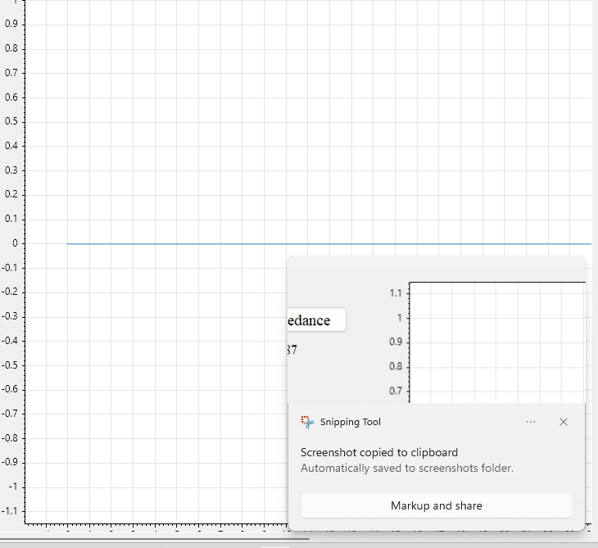
ECGR | Wavy line initially, but smooth | 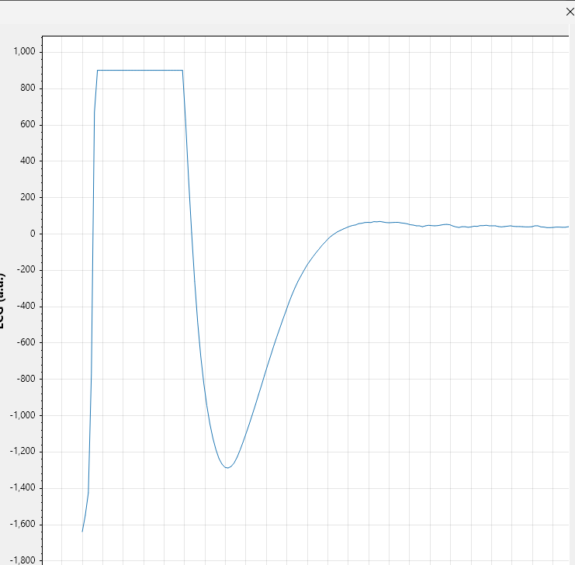
EMG1 | Some discontinuities, but mostly noise | 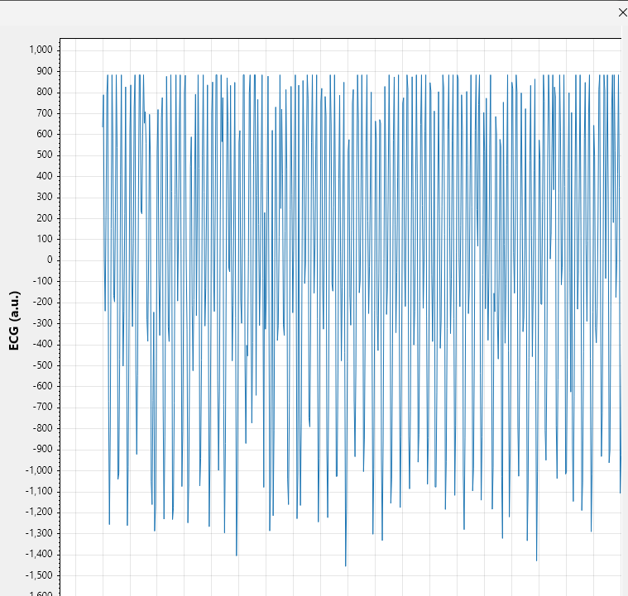
EMG2 | Some small discontinuities but mostly good | 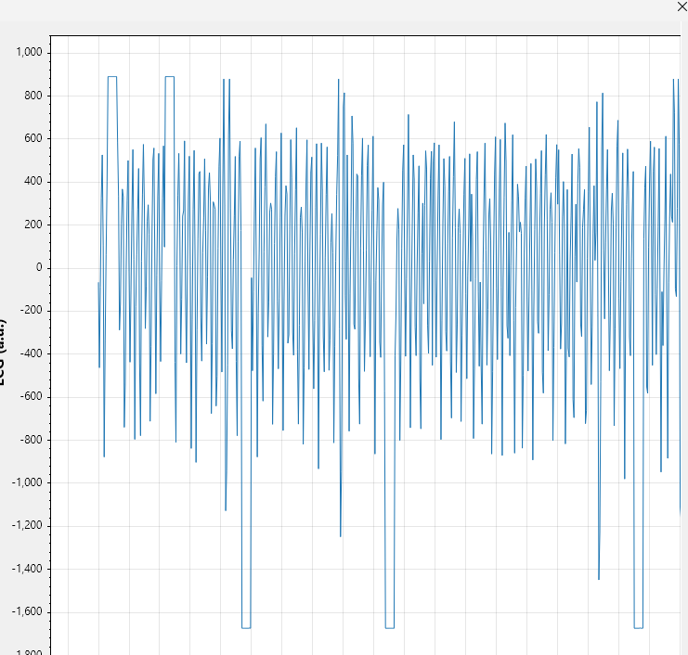

- Logs
  - Connect to the IPG. Clear logs. Read logs.
  - Start stimulation. Stop stimulation. Read logs again.
  - Pass criteria: able to save, clear, and form new logs
Result: Passed

- OTA updates
  - Connect and try OTA updates.
  - Pass criteria: firmware fully updates, board works afterwards

